Project Design Phase
Solution Architecture

Date | 20 February 2026
Team ID | LTVIP2026TMIDS73549
Project Name | Streamlining Ticket Assignment for Efficient Support Operations
Maximum Marks | 4 Marks

Solution Architecture:
Solution architecture represents the structured design of the ServiceNow Operations Ticket Management System, which automates operational issue handling through workflow automation and intelligent ticket routing.
The architecture connects organizational operational problems with ServiceNow platform capabilities to ensure efficient issue tracking, assignment, and resolution.
The goals of the proposed solution architecture are:
- To automate operational ticket management using ServiceNow workflows.
- To reduce manual ticket assignment and processing delays.
- To provide role-based secure access to users and support teams.
- To improve issue resolution efficiency through automated routing.
- To enable centralized monitoring and management of operational incidents.

Architecture Components
1. User Layer
Users interact with the system through the ServiceNow portal to:
- Create operational tickets
- Report platform or certificate issues
- Track ticket status and updates
2. Application Processing Layer
The application logic is implemented using:
- ServiceNow Flow Designer
- Business rules
- Automated workflows
This layer validates issues and determines appropriate ticket routing.
3. Data Layer
Operational data is stored in the custom table:
u_operations_related
The table maintains:
- Issue type
- Assigned group
- Ticket status
- User information
- Resolution details
4. Automation Layer
Automation is achieved through:
- Flow Designer workflows
- Access Control Lists (ACL)
- Role-based permissions
Tickets are automatically assigned based on issue category.
5. Support Group Layer
Tickets are routed to:
- L1 Support Team
- L2 Support Team
- Platform Support Group
- Certificate Support Group
Support teams resolve issues and update records.
6. Notification Layer
System notifications inform users regarding:
- Ticket creation
- Assignment updates
- Resolution completion

Example - Solution Architecture Diagram:
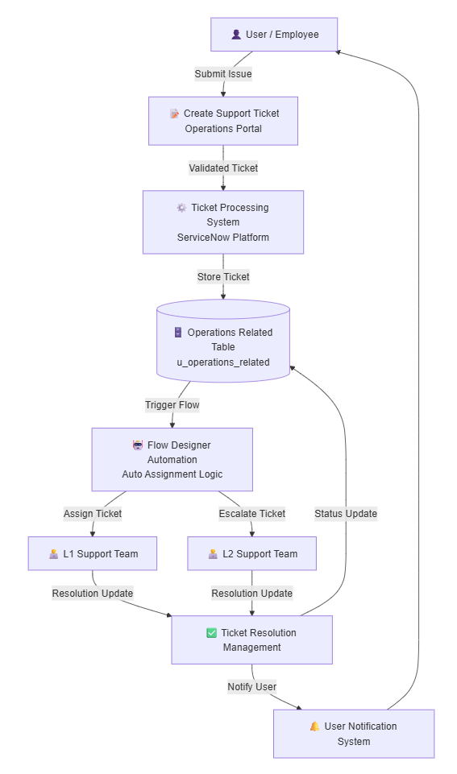
Figure 1: Architecture and data flow of the ServiceNow Operations Ticket Management System.

Reference: ServiceNow Documentation – Workflow Automation and Flow Designer Architecture.

